Yohanes Dimas Pratama

A11.2021.13254 - A11.4518

***Tugas 2 – Virtualisasi***

Ubuntu Server 1

Insert command -> sudo nano /etc/netplan/00-installer-config.yaml

Atur konfigurasi

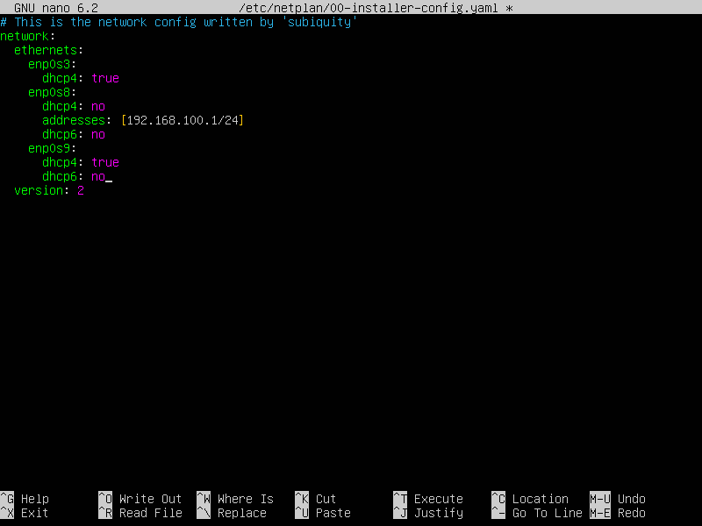

Insert command -> sudo netplan apply

Insert command -> ip addr

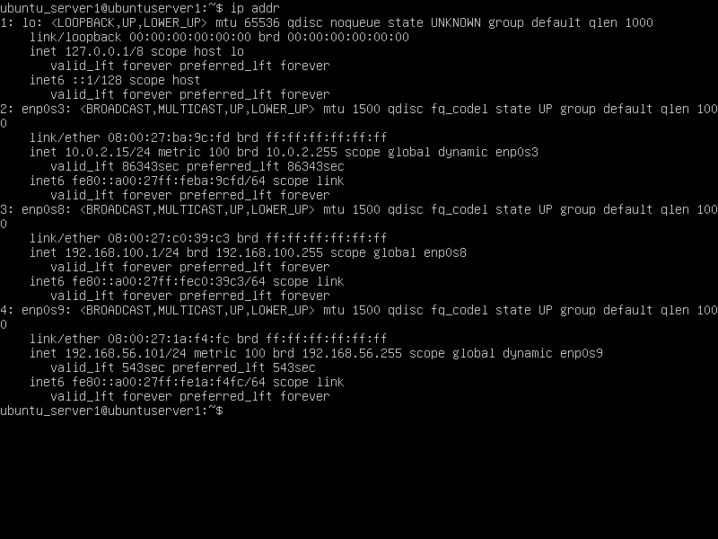

Ubuntu Server 2

Insert command -> sudo nano /etc/netplan/00-installer-config.yaml

Atur konfigurasi

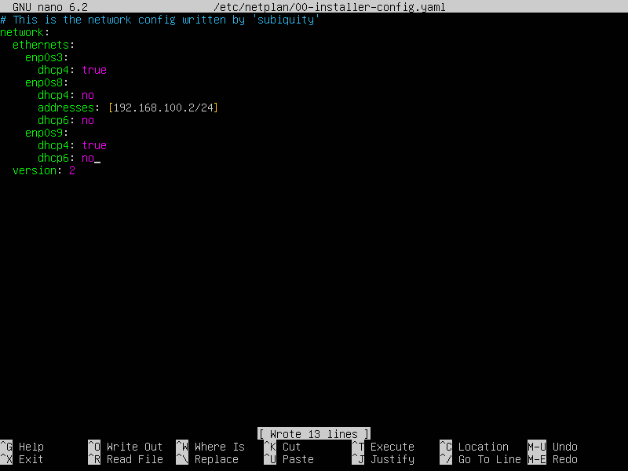

Insert command -> sudo netplan apply

Insert command -> ip addr

